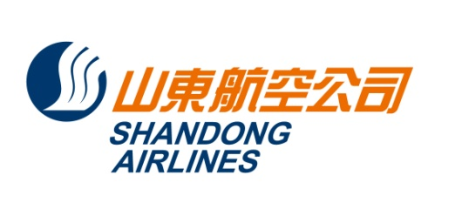
No.902,116 Sogong-ro, Jung-Gu, Seoul,Korea Zip: 04533
Tel: 82-2-773-9231 Fax: 82-2-776-5051

문서번호 : 21-F005
수신 : 각 SC여객대리점 및 BSP여행사
참조 : SC 발권 담당 및 관련 부서
제목 :산동항공 인천출발 연대(YNT) 정규운임(2021.03.28-2021.12.31)
출발일: 2021.03.28-2021.12.31
(2021.07.24-08.13, 09.18-09.23제외)

(출발일기준/KRW)
노선 | CLASS | F/B |  | 판매가 |  | 유효기간 | 리턴 | 날짜변경 | 환불수수료
 |  |  |  |  |  |  | OPEN | 수수료
ICN-YNT | C | COWKR6 |  | 468000 |  |  | 가능 | 137900 | 468000
 |  |  | CRTKR6 |  | 720000 | 12M
 |  |  | C6MKR6 |  | 680000 | 6M
 |  |  |  |  |  | 3M
 | D | DOWKR6 |  | 422500 |  |  | 가능 | 무료 | 30000
 |  |  | DRTKR6 |  | 650000 | 12M
 |  |  | D6MKR6 |  | 600000 | 6M
 |  |  |  |  |  | 3M
 | Y | YOWKR6 |  | 364000 |  |  | 가능 | 87000 | 174000
 |  |  | YRTKR6 |  | 560400 | 12M
 |  |  |  |  |  | 3M
 | B | BOWKR6 |  | 276000
 |  |  | BRTKR6 |  | 460000 | 12M
 |  |  | B6MKR6 |  | 420000 | 6M
 | H | HOWKR6 |  | 240000
 |  |  | HRTKR6 |  | 400000 | 12M
 |  |  | H6MKR6 |  | 360000 | 6M
 | L | LOWKR6 |  | 216000
 |  |  | LRTKR6 |  | 360000 | 12M
 |  |  | L6MKR6 |  | 320000 | 6M
 | Q | QOWKR6 |  | 192000
 |  |  | QRTKR6 |  | 320000 | 12M
 |  |  | Q6MKR6 |  | 280000 | 6M
 | G | GOWKR6 |  | 168000
 |  |  | G6MKR6 |  | 280000 | 6M
 |  |  | G3MKR6 |  | 240000 | 3M
 | V | VOWKR6 |  | 132000 |  |  | 가능 | 무료 | 20000
 |  |  | V6MKR6 |  | 220000 | 6M
 |  |  | V3MKR6 |  | 200000 | 3M
 | U | UOWKR6 |  | 108000
 |  |  | U3MKR6 |  | 180000 | 3M
 |  |  |  |  |  | 1M

**적용 조건**
(1) OZ/ CA Code Share 항공편 적용 불가. SC FLT로 예약/발권 진행.
(2) 다른 클래스와 결합 사용 가능
(3) 운임 및 기타 자세한 사용 조건은 변경 될 수 있으며 GDS 규정을 확인해 주시기 바랍니다.
(4) GDS update 완료, 메뉴얼(DC)발권 불가
TOURE CODE: ICN2105

2021. 03.28.
山東航空公司首爾支店

